Experiment 1 : Implement and demonstrate the FIND-S algorithm for finding the most specific hypothesis based on a given set of training data samples.
# Find-S Algorithm in Python
def find_s(examples):
# Step 1: Initialize hypothesis with the first positive example
for example in examples:
if example[-1] == "Yes":
hypothesis = example[:-1]
break
# Step 2: For each positive example, generalize hypothesis
for example in examples:
if example[-1] == "Yes":
for i in range(len(hypothesis)):
if hypothesis[i] != example[i]:
hypothesis[i] = "?"
return hypothesis
# Training data (EnjoySport Example)
data = [
['Sunny', 'Warm', 'Normal', 'Strong', 'Warm', 'Same', 'Yes'],
['Sunny', 'Warm', 'High', 'Strong', 'Warm', 'Same', 'Yes'],
['Rainy', 'Cold', 'High', 'Strong', 'Warm', 'Change', 'No']
]
final_hypothesis = find_s(data)
print("Most Specific Hypothesis:", final_hypothesis)

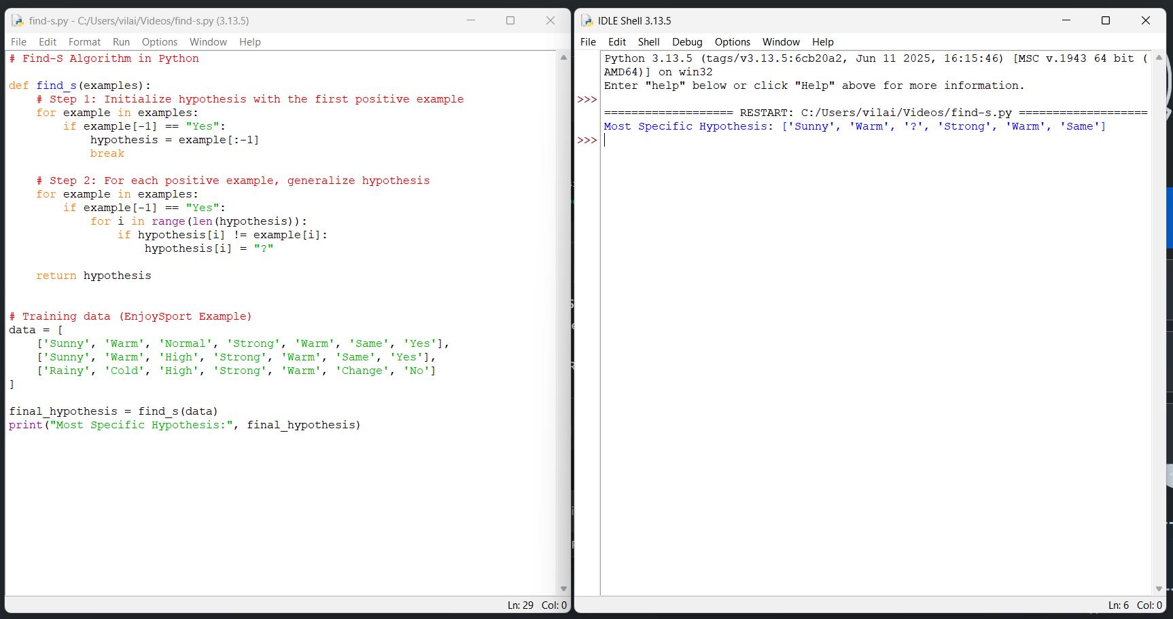
Experiment 2 : For a given set of training data examples stored in a .CSV file, implement and demonstrate the Candidate-Elimination algorithm in python to output a description of the set of all hypotheses consistent with the training examples
# Candidate Elimination Algorithm in Python
def more_general(h1, h2):
"""Check if hypothesis h1 is more general than h2"""
more_general_parts = []
for x, y in zip(h1, h2):
mg = x == "?" or (x != "?" and x == y)
more_general_parts.append(mg)
return all(more_general_parts)
def candidate_elimination(data):
# Initialize S as the first positive example
S = None
for row in data:
if row[-1] == "Yes":
S = row[:-1]
break
# Initialize G as most general hypothesis
G = [["?" for _ in range(len(S))]]
for row in data:
example, label = row[:-1], row[-1]
if label == "Yes":
# Remove from G any hypothesis inconsistent with example
G = [g for g in G if more_general(g, example)]
# Update S to be as specific as possible
for i in range(len(S)):
if S[i] != example[i]:
S[i] = "?"
else: # Negative example
# Remove S if it incorrectly classifies negative example
if more_general(S, example):
# Specialize G
new_G = []
for g in G:
for i in range(len(g)):
if g[i] == "?":
new_h = g.copy()
new_h[i] = S[i]
if not more_general(new_h, example):
new_G.append(new_h)
G = new_G
return S, G
# Training data (EnjoySport)
dataset = [
['Sunny','Warm','Normal','Strong','Warm','Same','Yes'],
['Sunny','Warm','High','Strong','Warm','Same','Yes'],
['Rainy','Cold','High','Strong','Warm','Change','No'],
['Sunny','Cold','High','Strong','Cool','Change','Yes'],
['Cloudy','Warm','Normal','Weak','Warm','Same','Yes'],
]
S, G = candidate_elimination(dataset)
print("Specific Boundary (S):", S)
print("General Boundary (G):", G)
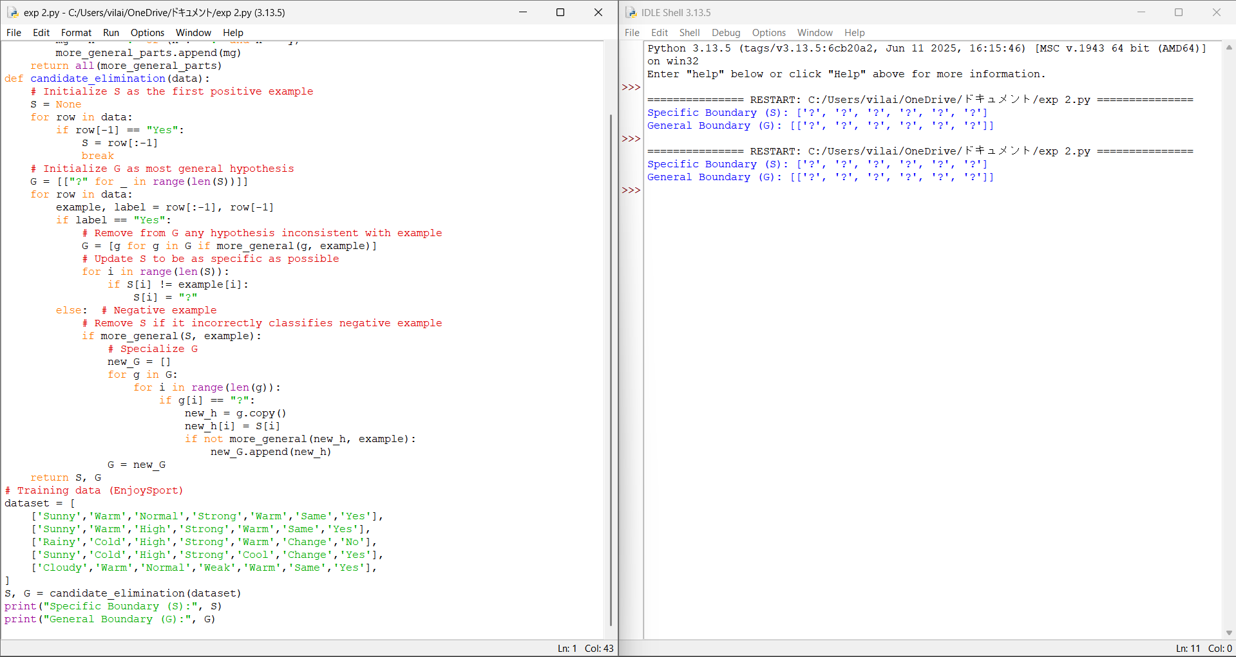

Experiment 3 : Demonstrate the working of the decision tree based ID3 algorithm. Use an appropriate data set for building the decision tree and apply this knowledge to classify a new sample.
import math
# Calculate entropy
def entropy(data):
labels = [row[-1] for row in data]
unique_labels = set(labels)
ent = 0
for label in unique_labels:
p = labels.count(label) / len(labels)
ent -= p * math.log2(p)
return ent
# Calculate Information Gain
def info_gain(data, col):
total_entropy = entropy(data)
values = set([row[col] for row in data])
weighted_entropy = 0
for v in values:
subset = [row for row in data if row[col] == v]
weighted_entropy += (len(subset) / len(data)) * entropy(subset)
return total_entropy - weighted_entropy
# ID3 Algorithm
def id3(data, features):
labels = [row[-1] for row in data]
# If all outputs are same → return that label
if labels.count(labels[0]) == len(labels):
return labels[0]
# If no features left
if not features:
return max(set(labels), key=labels.count)
# Find best attribute
gains = [info_gain(data, col) for col in features]
best_col = features[gains.index(max(gains))]
best_feature = "Feature_" + str(best_col)
tree = {best_feature: {}}
values = set(row[best_col] for row in data)
for v in values:
subset = [row for row in data if row[best_col] == v]
if not subset:
tree[best_feature][v] = max(set(labels), key=labels.count)
else:
new_features = [f for f in features if f != best_col]
tree[best_feature][v] = id3(subset, new_features)
return tree
# Sample dataset (Outlook, Temperature, Humidity, Wind, Play?)
dataset = [
['Sunny', 'Hot', 'High', 'Weak', 'No'],
['Sunny', 'Hot', 'High', 'Strong', 'No'],
['Overcast','Hot','High', 'Weak', 'Yes'],
['Rain', 'Mild', 'High', 'Weak', 'Yes'],
['Rain', 'Cool', 'Normal', 'Weak', 'Yes'],
['Rain', 'Cool', 'Normal', 'Strong', 'No'],
['Overcast','Cool','Normal','Strong','Yes'],
['Sunny', 'Mild', 'High', 'Weak', 'No'],
]
# Run ID3
features = [0, 1, 2, 3] # column indices
tree = id3(dataset, features)
print("Decision Tree:")
print(tree)
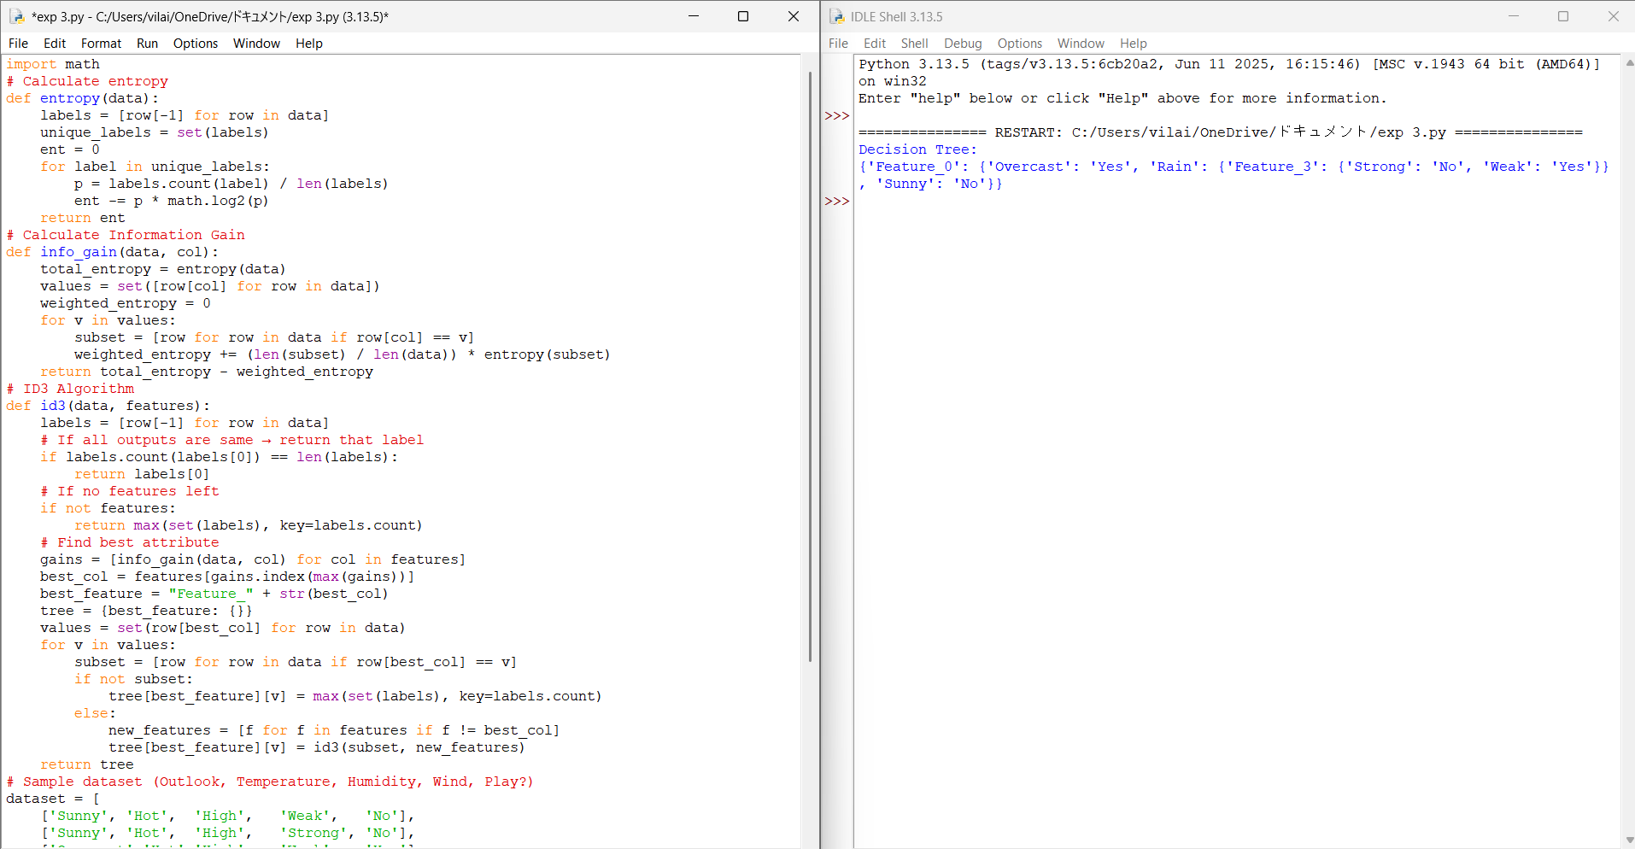
Experiment 4 : Build an Artificial Neural Network by implementing the Backpropagation algorithm and test the same using appropriate data sets.

# Perceptron Learning Algorithm for AND Gate
# Training data: [x1, x2, target]
training_data = [
[0, 0, 0],
[0, 1, 0],
[1, 0, 0],
[1, 1, 1]
]
# Initialize weights and bias
w1 = 0
w2 = 0
b = 0
lr = 1 # learning rate
# Activation function
def activation(x):
return 1 if x >= 0 else 0
# Training loop
for epoch in range(10):
print("Epoch:", epoch)
errors = 0
for x1, x2, target in training_data:
y = activation(w1*x1 + w2*x2 + b)
e = target - y
# Update rule
w1 = w1 + lr * e * x1
w2 = w2 + lr * e * x2
b = b + lr * e
errors += abs(e)
print(f"Input: {x1, x2}, Target: {target}, Output: {y}, Error: {e}")
if errors == 0:
print("Training complete!")
break
print("\nFinal Weights:")
print("w1 =", w1, ", w2 =", w2, ", bias =", b)
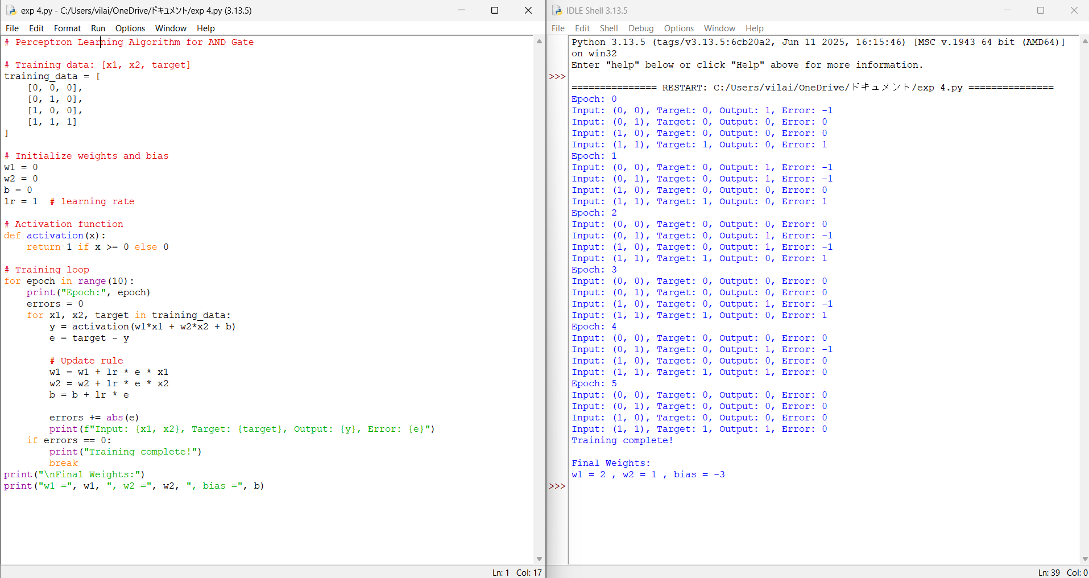

Experiment 5 : Write a program for Implementation of K-Nearest Neighbours (K-NN) in Python
# KNN Algorithm Implementation in Python
import math
# Calculate Euclidean Distance
def distance(p1, p2):
return math.sqrt(sum((a - b)**2 for a, b in zip(p1, p2)))
# KNN Function
def knn(training_data, test_point, k=3):
distances = []
for features, label in training_data:
dist = distance(features, test_point)
distances.append((dist, label))
# Sort by distance
distances.sort(key=lambda x: x[0])
# Get K nearest labels
k_neighbors = [label for _, label in distances[:k]]
# Majority vote
prediction = max(set(k_neighbors), key=k_neighbors.count)
return prediction
# Training dataset: ([features], label)
dataset = [
([2, 4], "A"),
([4, 6], "A"),
([4, 2], "A"),
([9, 10], "B"),
([10, 12], "B"),
([11, 9], "B")
]
test_sample = [5, 5]
pred = knn(dataset, test_sample, k=3)
print("Predicted Class:", pred)
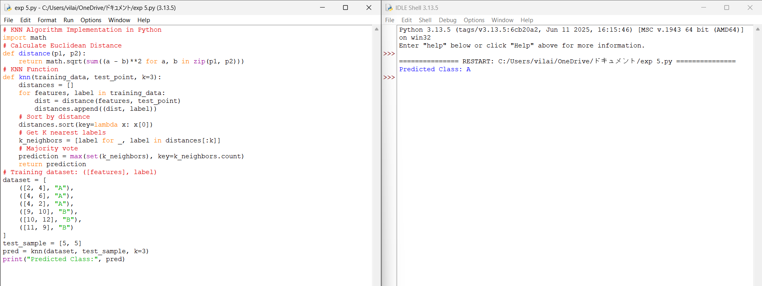

Exp 6 : Write a program to implement Naïve Bayes algorithm in python and to display the results using confusion matrix and accuracy.
Program:
# Import required libraries
import numpy as np
from sklearn.naive_bayes import GaussianNB
from sklearn.metrics import confusion_matrix, accuracy_score
from sklearn.model_selection import train_test_split
# Features: [Height, Weight]
X = np.array([
[160, 55],
[165, 60],
[170, 65],
[175, 70],
[180, 80],
[155, 48],
[158, 50],
[162, 54]
])

# Labels: 0 = Female, 1 = Male
y = np.array([0, 0, 1, 1, 1, 0, 0, 0])
X_train, X_test, y_train, y_test = train_test_split(
X, y, test_size=0.25, random_state=42
)
model = GaussianNB()
model.fit(X_train, y_train)
y_pred = model.predict(X_test)
cm = confusion_matrix(y_test, y_pred)
accuracy = accuracy_score(y_test, y_pred)
print("Confusion Matrix:")
print(cm)
print("\nAccuracy:")
print(accuracy)
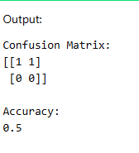
Exp 7 : Write a program to implement Logistic Regression (LR) algorithm in python
Program:
import math

# Sigmoid function
def sigmoid(z):
return 1 / (1 + math.exp(-z))

# Training data
X = [[1, 1], [2, 1], [3, 2], [4, 3]]
y = [0, 0, 1, 1]

# Initialize weights and bias
w1 = w2 = b = 0
lr = 0.1

# Training using Gradient Descent
for _ in range(1000):
for i in range(len(X)):
z = w1 * X[i][0] + w2 * X[i][1] + b
y_pred = sigmoid(z)

w1 += lr * (y[i] - y_pred) * X[i][0]
w2 += lr * (y[i] - y_pred) * X[i][1]
b += lr * (y[i] - y_pred)

# Prediction
print("Logistic Regression Predictions:")
for i in range(len(X)):
z = w1 * X[i][0] + w2 * X[i][1] + b
print(sigmoid(z))
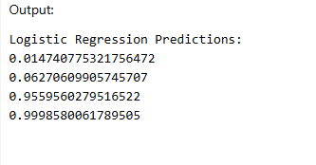

Exp 8: Write a program to implement Linear Regression (LR) algorithm in python
Program:
X = [1, 2, 3, 4, 5]
y = [2, 4, 5, 4, 5]
n = len(X)
mean_x = sum(X) / n
mean_y = sum(y) / n
num = den = 0
for i in range(n):
num += (X[i] - mean_x) * (y[i] - mean_y)
den += (X[i] - mean_x) ** 2
m = num / den
c = mean_y - m * mean_x
print("Slope (m):", m)
print("Intercept (c):", c)
print("Predicted values:")
for x in X:
print(m * x + c)
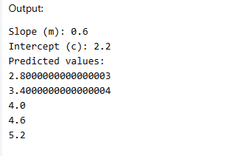

Exp 9: Compare Linear and Polynomial Regression using Python
Program:
import numpy as np
# Data
X = np.array([1, 2, 3, 4, 5])
y = np.array([2, 4, 5, 4, 5])
# Linear Regression
coef = np.polyfit(X, y, 1)
linear_pred = np.polyval(coef, X)
# Polynomial Regression (degree = 2)
poly_coef = np.polyfit(X, y, 2)
poly_pred = np.polyval(poly_coef, X)
# Mean Squared Error
linear_mse = np.mean((y - linear_pred) ** 2)
poly_mse = np.mean((y - poly_pred) ** 2)
print("Linear Regression MSE:", linear_mse)
print("Polynomial Regression MSE:", poly_mse)
if poly_mse < linear_mse:
print("Polynomial Regression performs better")
else:
print("Linear Regression performs better")
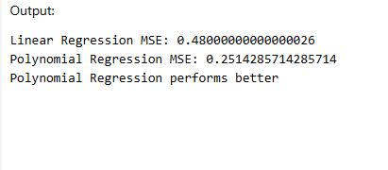

Exp 10: Write a Python Program to Implement Expectation & Maximization Algorithm
Program:
# EM Algorithm Example – Coin Toss
import random
# Observed data (number of heads in 10 tosses)
data = [5, 9, 8, 4, 7]
# Initial probabilities
pA = 0.6
pB = 0.5
for iteration in range(5):
expA = expB = 0
for heads in data:
probA = (pA ** heads) * ((1 - pA) ** (10 - heads))
probB = (pB ** heads) * ((1 - pB) ** (10 - heads))
weightA = probA / (probA + probB)
weightB = probB / (probA + probB)
expA += weightA * heads
expB += weightB * heads
# Maximization step
pA = expA / (10 * len(data))
pB = expB / (10 * len(data))
print(f"Iteration {iteration+1}: pA={pA:.3f}, pB={pB:.3f}")
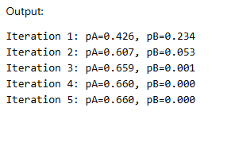
Exp 11 : Write a program for the task of Credit Score Classification
Program:
# Credit Score Classification using Logistic Regression

import pandas as pd
from sklearn.model_selection import train_test_split
from sklearn.preprocessing import LabelEncoder
from sklearn.linear_model import LogisticRegression
from sklearn.metrics import accuracy_score, classification_report

# Step 1: Create sample dataset
data = {
'Income': [500000, 300000, 700000, 200000, 900000],
'Monthly_Salary': [40000, 25000, 60000, 15000, 75000],
'Credit_Cards': [2, 3, 1, 4, 1],
'Debt': [50000, 120000, 30000, 200000, 20000],
'Credit_Score': ['Good', 'Standard', 'Good', 'Poor', 'Good']
}

df = pd.DataFrame(data)

# Step 2: Encode target labels
le = LabelEncoder()
df['Credit_Score'] = le.fit_transform(df['Credit_Score'])
# Step 3: Split features and target
X = df.drop('Credit_Score', axis=1)
y = df['Credit_Score']
# Step 4: Train-test split
X_train, X_test, y_train, y_test = train_test_split(
X, y, test_size=0.2, random_state=42
)
# Step 5: Train Logistic Regression model
model = LogisticRegression()
model.fit(X_train, y_train)
# Step 6: Prediction
y_pred = model.predict(X_test)
# Step 7: Evaluation
print("Accuracy:", accuracy_score(y_test, y_pred))
print("\nClassification Report:\n", classification_report(y_test, y_pred))

# Step 8: Predict for new customer
new_customer = [[600000, 50000, 2, 40000]]
prediction = model.predict(new_customer)
print("Predicted Credit Score:", le.inverse_transform(prediction))
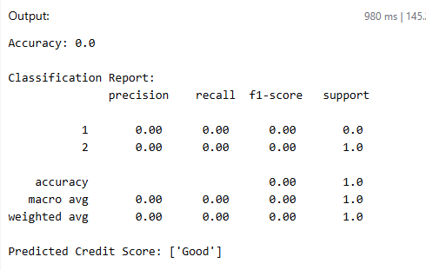

Exp 12: Implement Iris Flower Classification using KNN
Program:
from sklearn.datasets import load_iris
from sklearn.model_selection import train_test_split
from sklearn.neighbors import KNeighborsClassifier
from sklearn.metrics import accuracy_score, confusion_matrix, classification_report
iris = load_iris()
X = iris.data # features
y = iris.target # labels

X_train, X_test, y_train, y_test = train_test_split(
X, y, test_size=0.2, random_state=42
)
knn = KNeighborsClassifier(n_neighbors=5)
knn.fit(X_train, y_train)
y_pred = knn.predict(X_test)
print("Accuracy:", accuracy_score(y_test, y_pred))
print("\nConfusion Matrix:\n", confusion_matrix(y_test, y_pred))
print("\nClassification Report:\n", classification_report(y_test, y_pred))
sample = [[5.1, 3.5, 1.4, 0.2]] # example flower data
prediction = knn.predict(sample)
print("\nPredicted Flower:", iris.target_names[prediction][0])
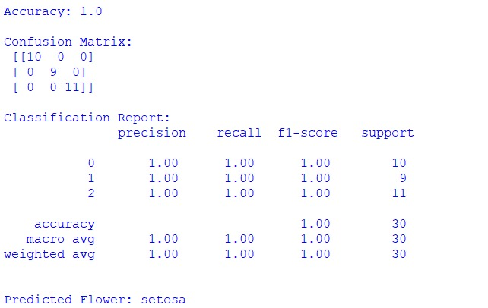

Exp 13 Implement the Car Price Prediction Model using Python
Program:
years = [2015, 2016, 2017, 2018, 2019, 2020, 2021]
present_price = [5.5, 6.0, 6.8, 7.2, 8.0, 8.5, 9.0]
kms_driven = [50000, 40000, 30000, 25000, 20000, 15000, 10000]
selling_price = [3.5, 4.0, 4.8, 5.5, 6.5, 7.2, 8.0]
kms = [k/10000 for k in kms_driven]
def predict_price(year, price, km):
base = (price * 0.6) + ((2025 - year) * -0.3) + (km * -0.2)
return round(base, 2)
year = 2019
price = 8.0
km = 20000 / 10000
predicted = predict_price(year, price, km)
print("Predicted Car Price (in lakhs):", predicted)
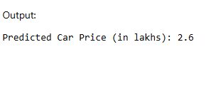

Exp 14 Implement House price Prediction using appropriate machine learning algorithm
Program:
area = [600, 800, 1000, 1200, 1500, 1800, 2000]
price = [20, 25, 30, 38, 45, 55, 65]
mean_area = sum(area) / len(area)
mean_price = sum(price) / len(price)
num = 0
den = 0
for i in range(len(area)):
num += (area[i] - mean_area) * (price[i] - mean_price)
den += (area[i] - mean_area) ** 2

b1 = num / den # slope
b0 = mean_price - b1 * mean_area # intercept
def predict_house_price(a):
return round(b0 + b1 * a, 2)
test_area = 1400
predicted_price = predict_house_price(test_area)
print("Area (sq.ft):", test_area)
print("Predicted House Price (in lakhs):", predicted_price)
Output:
Area (sq.ft): 1400
Predicted House Price (in lakhs): 43.75

Exp 15: Implement Iris Flower Classification using Naive Bayes classifier
Program:
import math
X = [
[5.1,3.5,1.4,0.2], [4.9,3.0,1.4,0.2], [5.0,3.4,1.5,0.2], # Setosa
[6.4,3.2,4.5,1.5], [6.9,3.1,4.9,1.5], [5.5,2.3,4.0,1.3], # Versicolor
[6.5,3.0,5.2,2.0], [6.3,2.5,5.0,1.9], [6.7,3.1,5.6,2.4] # Virginica
]
y = [
'Setosa','Setosa','Setosa',
'Versicolor','Versicolor','Versicolor',
'Virginica','Virginica','Virginica'
]
def separate_by_class(X, y):
separated = {}
for i in range(len(X)):
if y[i] not in separated:
separated[y[i]] = []
separated[y[i]].append(X[i])
return separated
def mean(numbers):
return sum(numbers) / len(numbers)
def stdev(numbers):
avg = mean(numbers)
variance = sum((x-avg)**2 for x in numbers) / len(numbers)
return math.sqrt(variance)
def summarize(dataset):
summaries = [(mean(col), stdev(col)) for col in zip(*dataset)]
return summaries
def gaussian_prob(x, mean, stdev):
exponent = math.exp(-((x-mean)**2 / (2*stdev**2)))
return (1 / (math.sqrt(2*math.pi) * stdev)) * exponent
def train_nb(X, y):
separated = separate_by_class(X, y)
model = {}
for cls, rows in separated.items():
model[cls] = summarize(rows)
return model
def predict(model, row):
probabilities = {}
for cls, summaries in model.items():
probabilities[cls] = 1
for i in range(len(row)):
mean, stdev = summaries[i]
probabilities[cls] *= gaussian_prob(row[i], mean, stdev)
return max(probabilities, key=probabilities.get)
model = train_nb(X, y)
test_sample = [5.9, 3.0, 5.1, 1.8]
prediction = predict(model, test_sample)
print("Test Sample:", test_sample)
print("Predicted Flower:", prediction)
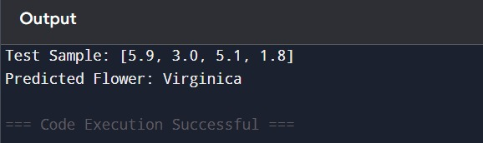

Exp 16: Compare different types Classification Algorithms and evaluate their performance.
Program:
from sklearn.datasets import load_iris
from sklearn.model_selection import train_test_split
from sklearn.neighbors import KNeighborsClassifier
from sklearn.naive_bayes import GaussianNB
from sklearn.tree import DecisionTreeClassifier
from sklearn.svm import SVC
from sklearn.metrics import accuracy_score
iris = load_iris()
X = iris.data
y = iris.target
X_train, X_test, y_train, y_test = train_test_split(
X, y, test_size=0.25, random_state=42
)
models = {
"KNN": KNeighborsClassifier(n_neighbors=3),
"Naive Bayes": GaussianNB(),
"Decision Tree": DecisionTreeClassifier(),
"SVM": SVC()
}
print("Classification Algorithm Performance:\n")
for name, model in models.items():
model.fit(X_train, y_train)
y_pred = model.predict(X_test)
accuracy = accuracy_score(y_test, y_pred)
print(f"{name} Accuracy: {accuracy:.2f}")
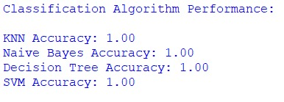

Exp :17 Implement Mobile Price Prediction using appropriate machine learning algorithm
Program:
def predict_mobile_price(ram, battery, storage, camera):
score = 0
if ram >= 8:
score += 3
elif ram >= 4:
score += 2
else:
score += 1
if battery >= 5000:
score += 3
elif battery >= 4000:
score += 2
else:
score += 1
if storage >= 128:
score += 3
elif storage >= 64:
score += 2
else:
score += 1
if camera >= 64:
score += 3
elif camera >= 32:
score += 2
else:
score += 1
if score >= 10:
return "High Price"
elif score >= 7:
return "Medium Price"
else:
return "Low Price"
ram = 6 # GB
battery = 4500 # mAh
storage = 128 # GB
camera = 64 # MP
result = predict_mobile_price(ram, battery, storage, camera)
print("Mobile Features:")
print("RAM:", ram, "GB")
print("Battery:", battery, "mAh")
print("Storage:", storage, "GB")
print("Camera:", camera, "MP")
print("\nPredicted Mobile Price Range:", result)
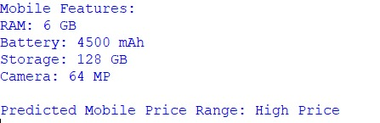

Exp 18: Implement Perceptron based IRIS classification
Program:
X = [
[5.1,3.5,1.4,0.2],
[4.9,3.0,1.4,0.2],
[5.0,3.4,1.5,0.2], # Setosa
[6.4,3.2,4.5,1.5],
[6.9,3.1,4.9,1.5],
[5.5,2.3,4.0,1.3], # Non-Setosa
]
# Labels: Setosa = 1, Non-Setosa = 0
y = [1, 1, 1, 0, 0, 0]
# Initialize weights and bias
weights = [0.0, 0.0, 0.0, 0.0]
bias = 0.0
learning_rate = 0.1
epochs = 10
# Activation function
def step_function(x):
return 1 if x >= 0 else 0
for epoch in range(epochs):
for i in range(len(X)):
net_input = sum(weights[j] * X[i][j] for j in range(4)) + bias
prediction = step_function(net_input)
error = y[i] - prediction
for j in range(4):
weights[j] += learning_rate * error * X[i][j]
bias += learning_rate * error
test_sample = [5.0, 3.6, 1.4, 0.2]
net_input = sum(weights[j] * test_sample[j] for j in range(4)) + bias
output = step_function(net_input)
print("Test Sample:", test_sample)
if output == 1:
print("Predicted Class: Setosa")
else:
print("Predicted Class: Non-Setosa")

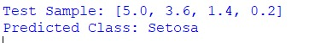
Output:

Exp 19: Implementation of Naive Bayes classification for Bank Loan prediction
Program:
from sklearn.model_selection import train_test_split
from sklearn.naive_bayes import GaussianNB
from sklearn.metrics import accuracy_score, confusion_matrix
X = [
[25, 30000, 650, 100000],
[35, 50000, 720, 200000],
[45, 80000, 750, 300000],
[23, 20000, 600, 50000],
[52, 100000, 780, 400000],
[40, 60000, 710, 250000],
[28, 35000, 680, 120000],
[48, 90000, 760, 350000]
]
# Target: Loan Approval (1 = Yes, 0 = No)
y = [0, 1, 1, 0, 1, 1, 0, 1]
X_train, X_test, y_train, y_test = train_test_split(
X, y, test_size=0.25, random_state=42
)
model = GaussianNB()
model.fit(X_train, y_train)
y_pred = model.predict(X_test)
print("Accuracy:", accuracy_score(y_test, y_pred))
print("Confusion Matrix:\n", confusion_matrix(y_test, y_pred))
new_customer = [[30, 45000, 700, 150000]]
prediction = model.predict(new_customer)
if prediction[0] == 1:
print("Loan Status: Approved")
else:
print("Loan Status: Not Approved")

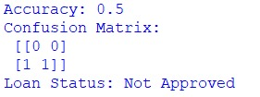
Output:

Exp 20: Implement Future Sales Prediction using a suitable machine learning algorithm
Program:
from sklearn.model_selection import train_test_split
from sklearn.linear_model import LinearRegression
from sklearn.metrics import mean_squared_error, r2_score
X = [
[1], [2], [3], [4],
[5], [6], [7], [8]
]
y = [3, 5, 7, 9, 11, 13, 15, 17]
X_train, X_test, y_train, y_test = train_test_split(
X, y, test_size=0.25, random_state=42
)

# Step 3: Train Linear Regression model
model = LinearRegression()
model.fit(X_train, y_train)
y_pred = model.predict(X_test)
print("Mean Squared Error:", mean_squared_error(y_test, y_pred))
print("R2 Score:", r2_score(y_test, y_pred))
future_ad_spend = [[9]]
future_sales = model.predict(future_ad_spend)
print("Predicted Future Sales:", future_sales[0])

Output:
